Defect id: 04

Description:

* File is not saved to local after downloading any ‘Picture of the day’ image

Severity:

* Medium

Priority:

* Medium

Steps to Reproduce:

1. Navigate to Home page
2. Click on ‘Download’ button on any ‘Picture of the day’ image

Actual Result:

* Image is not saved to local

Expected Result:

* Image should be saved to local after ‘File saved successfully’ info card displayed

Environment:

* Android 10 Virtual device using Android Studio on Windows

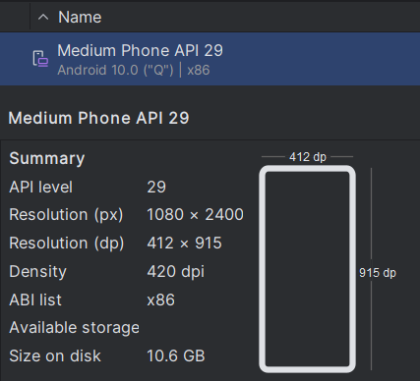

Evidence:

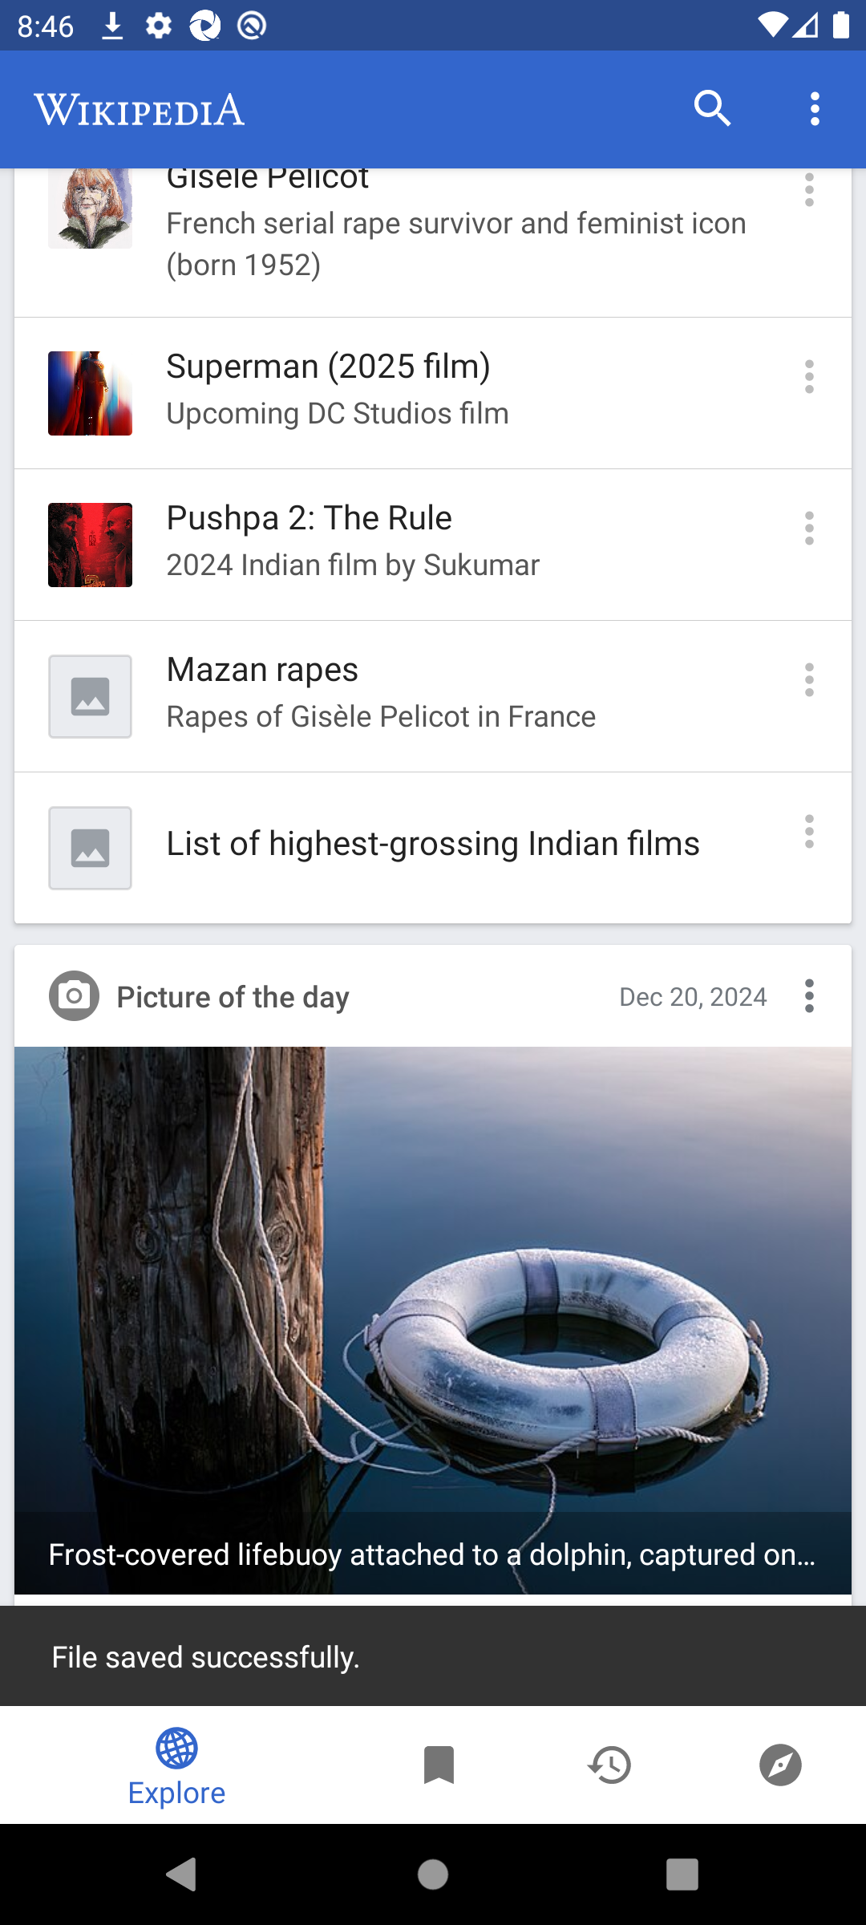

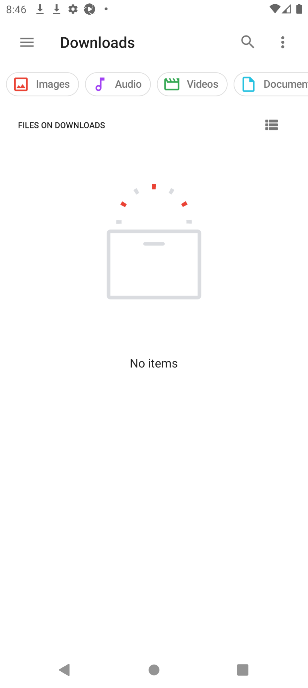z